Group Information

1. David Danko 2015, David Ashpole 2016

2. We would like to participate in the rookie division

3. Theme 3: Meeting New People. The point of our website is to meet people with similar interests and do projects with them.

4. We plan to use Django for our Server side programming

5. Technical ability and a lack of initial user base.

6. Yes.

User Research

1. Our application will help people find other people to do projects with.

2. Our application lists ongoing projects sorted by region and allows users to create new projects.

3. Everyone has hobbies and most people like to share those hobbies with others. Our website supports a broad range of activities. Users can search a category they're interested in and, because the site's categories are automatically location based, easily meet other people with similar interests.

     The site will also allow groups to track their projects progress. Users will be able to look at others finished projects and ask for help from the rest of the user base.

4. Any one with a hobby could be part of our target demographic. However we plan to initially restrict the website to the MIT campus. Initially restricting the availability of the website will allow us to gain users and content (MIT students are both web conscious and hobby heavy) before exposing the site to large amounts of traffic.

5. Users with technical expertise will probably end up using our site to give advice to less experienced users and post about their own projects rather than trying to do projects with significantly less experience.

7. Interviewing potential users suggested that we should focus more on letting users use our site to learn more about projects others have done and talk to more experienced people. We planned to support this anyways but it's useful to know that this feature is as important to potential users as meeting new people.

     The people we interviewed also suggested that they would use the meet feature to find people to do psets with.

8. Our two primary user personas are content consumers and meters. The former will explore the site to find work others have done and the latter will use the site to meet people to work with. We expect groups that used our site to meet to be more likely to post content.

9. A use case for a user trying to find a pset group:

1. User: navigate to home page

    Site: load home page

2. User: Search class number

    Site: search databases for tags matching the class number

            load matches

3. User: RSVP to convenient pset group

    Site: scrape users name from their certificate

            send a message to the user who created the event

Pros: Visually 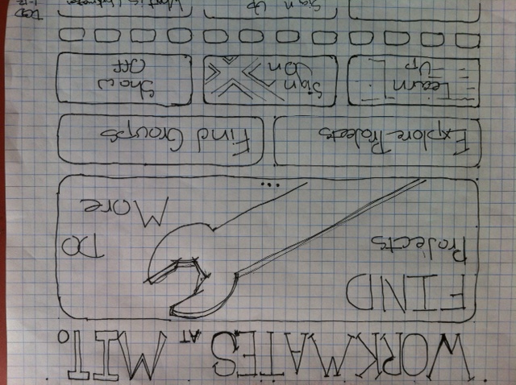Striking, lots of functionality, Large buttons

Cons: Lots of buttons, Large image looks like a link even though it isn’t, might be hard to make

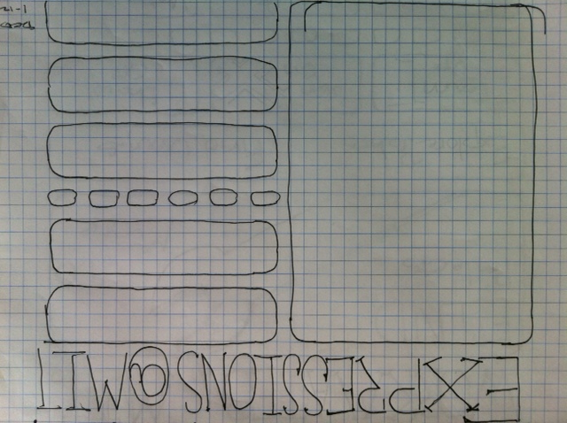Pros: Unique look, large buttons, lots of room for links to other parts of the site

Cons: A lot going on, buttons don’t have much visual hierarchy, Divides attention between left and right of screen.

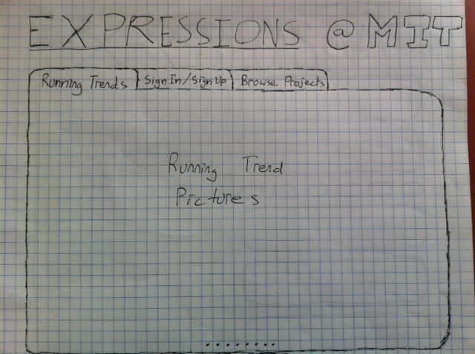Pros: Simple design, Pictures gets most of the screen at first, mall number of buttons

Cons: Not much functionality, buttons have no visual hierarchy, Small buttons

